**2. ER Diagram:**

The ER diagram visually represents the relationships between the entities .

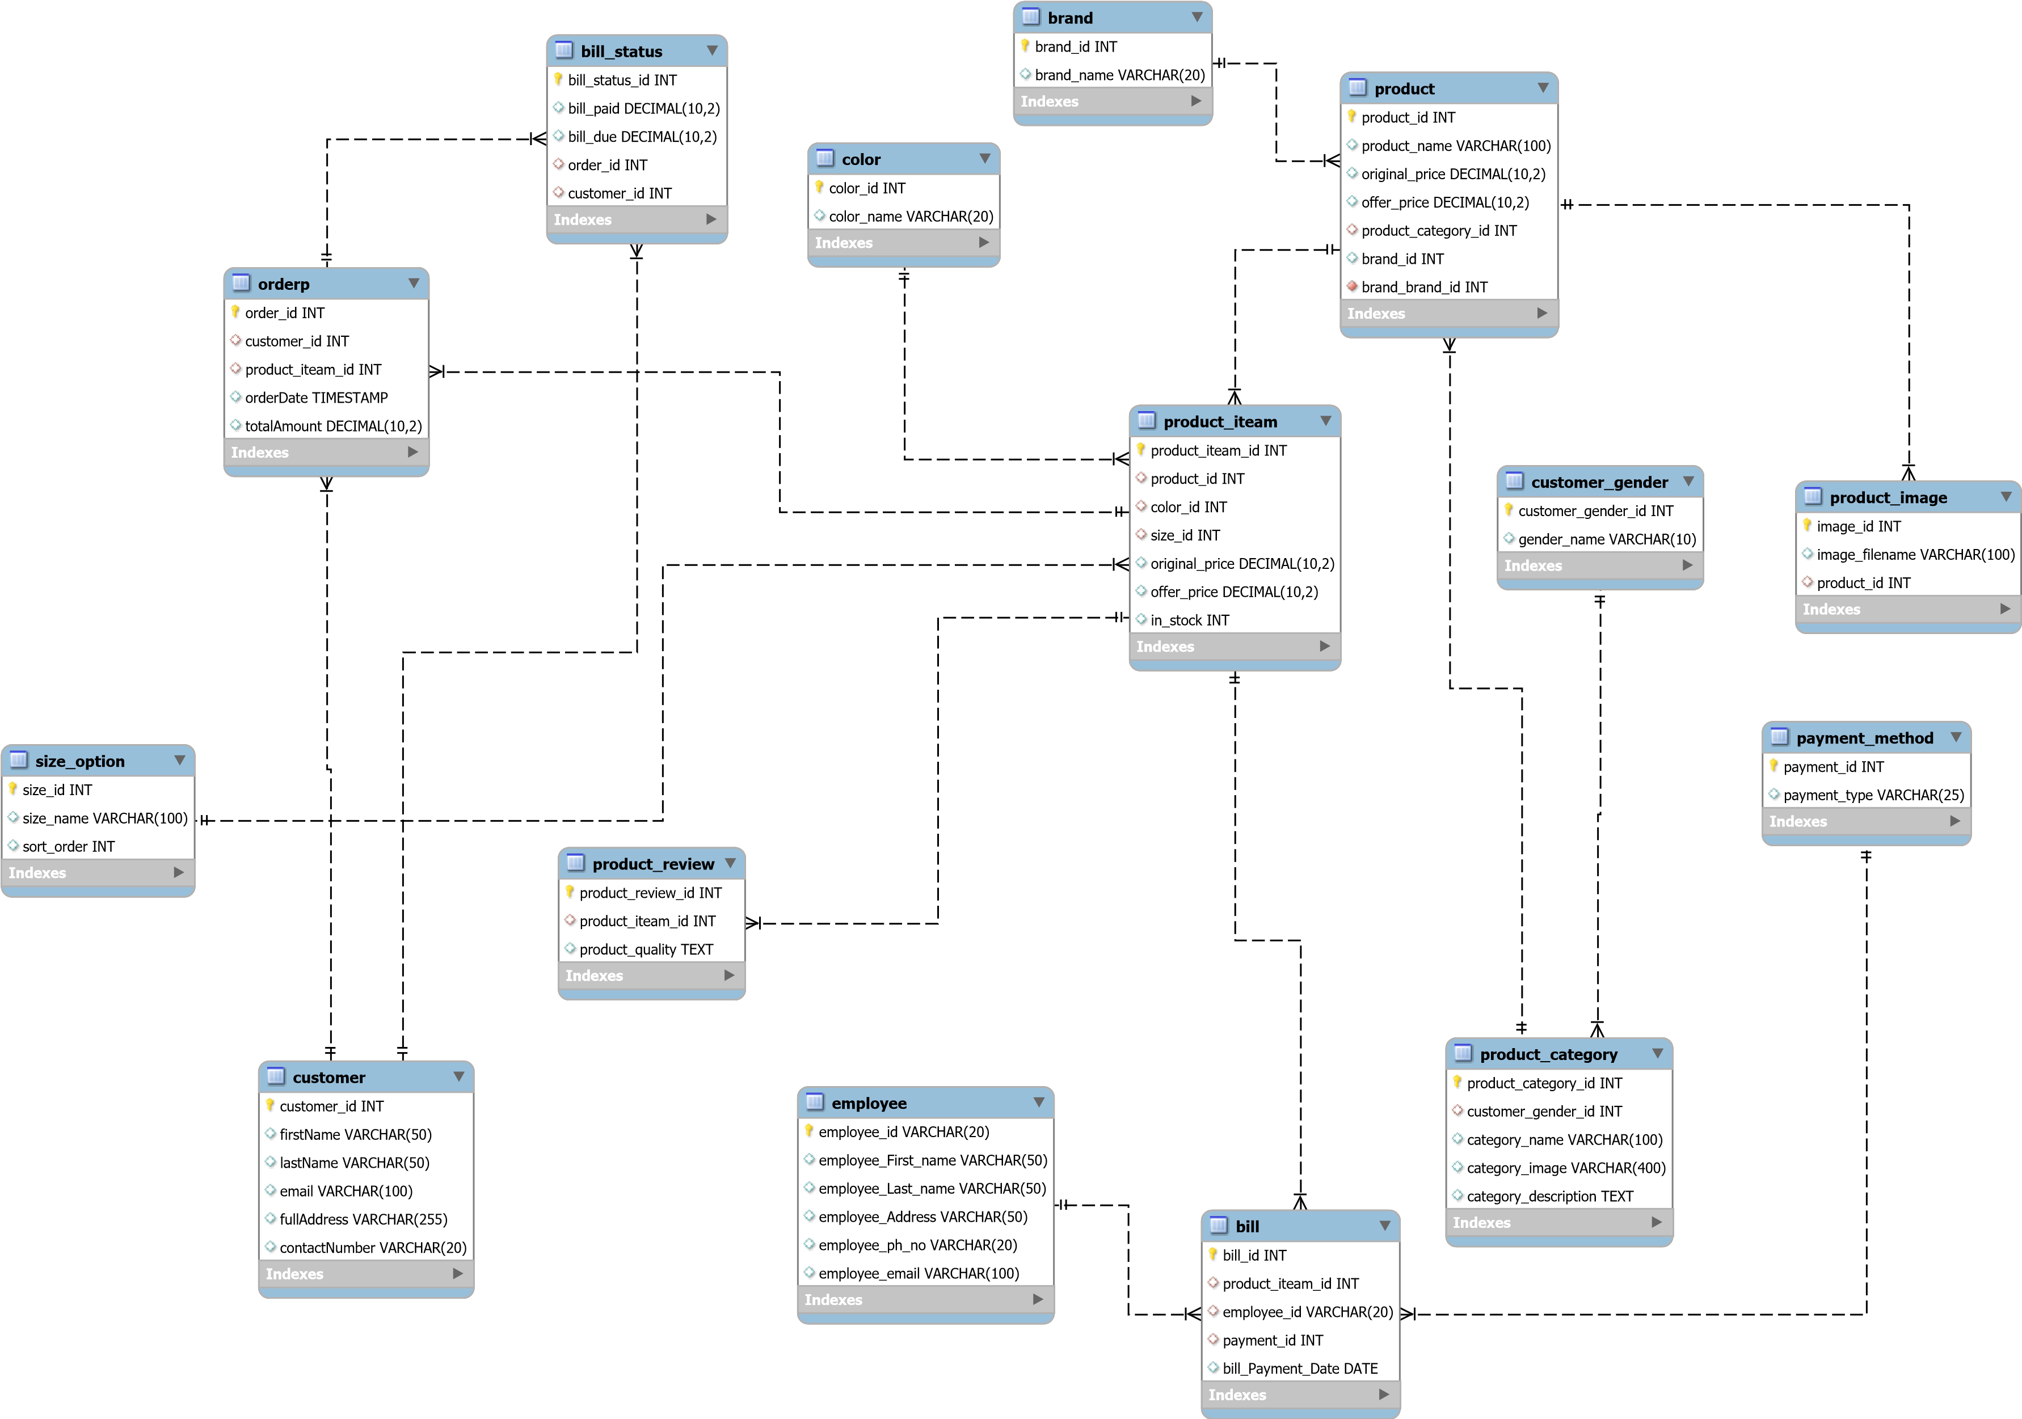The main entities include Users, Products, Categories, Orders, OrderDetails, Cart etc. Attributes and primary keys are defined for each’

# Online Shopping Application - Database Design

## 1. Database Design

Based on the project requirements, the following tables are proposed:

### 1. Users

* - UserID (Primary Key)
* - Name
* - Email (Unique)
* - Password
* - Address
* - Phone
* - Role (User/Admin)

### 2. Products

* - ProductID (Primary Key)
* - Name
* - Description
* - Price
* - Stock
* - CategoryID (Foreign Key)
* - ImageURL

### 3. Categories

* - CategoryID (Primary Key)
* - CategoryName

### 4. Orders

* - OrderID (Primary Key)
* - UserID (Foreign Key)
* - OrderDate
* - TotalAmount
* - Status (Pending/Shipped/Delivered)

### 5. OrderDetails

* - OrderDetailID (Primary Key)
* - OrderID (Foreign Key)
* - ProductID (Foreign Key)
* - Quantity
* - Subtotal

### 6. Cart

* - CartID (Primary Key)
* - UserID (Foreign Key)
* - ProductID (Foreign Key)
* - Quantity

Normalization